IOT Garbage Monitoring With Weight Sensing

Keeping the city clean has been always an ongoing task which needs laborious efforts of people working on ground level emptying the garbage bins whenever they are full. The event of garbage bin getting full is not strictly dependent on a time pattern, instead it sometimes becomes rapidly full or sometimes requires more than normal time to become full. IOT Garbage Monitoring with Weight Sensing project is an innovative step towards making this process more smooth and efficient.
This system monitors the garbage bins and informs about the level of garbage collected in the garbage bins via a web page. For this the system uses ultrasonic sensors placed over the bins to detect the garbage level and compare it with the garbage bins depth. In addition, we also have weight sensors attached below the garbage bins. Thus the system sends over the internet the level of fill of the garbage bins as well as the weight of the fill of the garbage bins. The advantage of this combo sensing is that the garbage bin lifting weight can also be known by the authorities. If the garbage bin is not filled up, but still the weight of fill has reached the limit of what the garbage lifting vehicles can pick up, the vehicles can be immediately driven towards that bin for evacuation. The system makes use of AVR family microcontroller, LCD screen, Wifi modem for sending data and a buzzer. The system is powered by a 12V transformer. The LCD screen is used to display the status of the level and weight of garbage collected in the bins. Whereas a web page is built to show the status to the user monitoring it. The web page gives a graphical view of the garbage bins and highlights the garbage collected in colour in order to show the level of garbage collected. Also the weight of the individual bins will get displayed along with the level of the garbage bin. The LCD screen shows the status of the garbage level. The system puts on the buzzer when the level of garbage collected crosses the set limit. Thus this system helps to keep the city clean by informing about the garbage levels of the bins by providing graphical image of the bins via IOT Gecko web development platform.

Block Diagram :
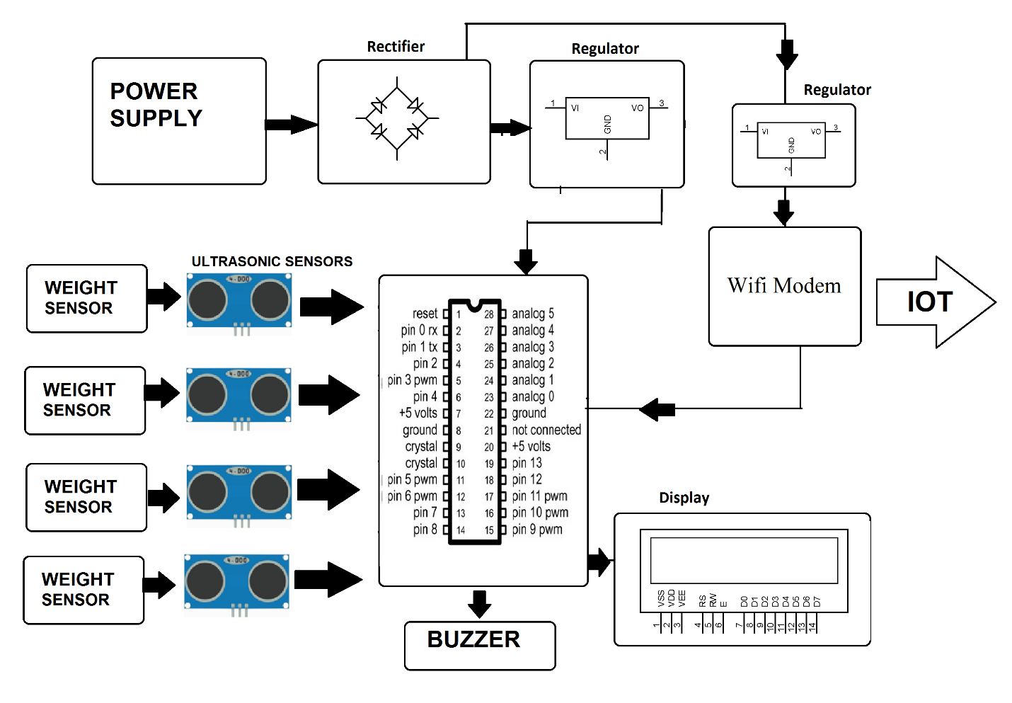

Hardware Specifications
- ATmega328P AVR MC
- HC-SR04 Ultrasonic
- Weight Sensor
- ESP8266 Wifi Module
- Buzzer
- LCD’s
- Crystal Oscillator
- Resistors
- Capacitors
- Transistors
- Cables & Connectors
- Diodes
- PCB
- LED’s
- Transformer/Adapter
- Push Button

Software Specifications
- Arduino Compiler
- MC Programming Language: C
- IOT Platform: IOT Gecko

